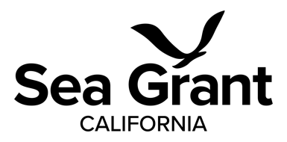

2026 California Sea Grant Biennial Request for Proposals

Full Proposal Checklist

Signed Institutional Cover Page (for each lead and subaward institution)

Project Summary

Project Narrative

Curriculum Vitae(s)

Current and Pending Support

Community Engagement Plan

Letter of Commitment

Letter(s) of Support

Budget Narrative (separate 90-4(s), justification, and scope of work required for all subawards)

90-4 Budget Form(s)

Budget Justification

Data Management Plan

Environmental Compliance Questionnaire (NEPA)

Generative AI disclosure

Demographics Questionnaire (Optional)